**ADVANCED DATABASE MANAGEMENT SYSTEM**

**ASSIGNMENT NO : 3**

**SUBMITTED BY,**

**GROUP III (11-15)**

**ARJUN V PANKAJAKSHAN**

**ARUN V DAS**

**ASWIN PRABHAKARAN**

**BLESSY P ROY**

**BRAHMADUTTAN S**

**TOPIC**: Design database schemas and implement min 10 queries using Cassandra column based databases

| **Aim** |
| --- |
| To Design database schemas and implement queries using Cassandra databases |

| **Objective(s)** | |
| --- | --- |
| **1** | Study of NOSQL Cassandra. |
| **2** | Study the procedure to execute a query using Apache Cassandra. |
| **3** | Execute min 10 queries using Cassandra column based database. |

**1.STUDY OF NOSQL CASSANDRA**

**Cassandra**

Apache Cassandra is an open source distributed database management

system designed to handle large amounts of data across many commodity servers, providing high availability with no single point of failure.

**Features**

* 1. **Scalability:**
     + Read and write throughput both increase linearly as new machines are added, with no downtime or interruption to applications.
  2. **Fault-tolerant:**
     + Data is automatically replicated to multiple nodes for fault-tolerance.
     + Replication across multiple data centers is supported.
     + Failed nodes can be replaced with no downtime.
  3. **MapReduce support:**
     + Cassandra has Hadoop integration, with MapReduce support.
  4. **Query language:**
     + Cassandra introduces CQL (Cassandra Query Language), a SQL-like alternative to the traditional RPC interface.
       - **Keyspace:** Keyspace is the outermost container for data.It is similar to the schema in a relational database.

**Basic attributes** of Keyspace are:

* **Replication Factor:** It is the number of machines in the cluster that will receive copies of the same data
* **Replica Placement Strategy:** It is a strategy to place replicas in the ring
* Simple Strategy,
* Old Network Topology Strategy
* Network Topology Strategy

**Column Families:** Column family is a NoSQL object that contains columns of related data. It is a tuple (pair) that consists of a key-value pair, where the key is mapped to a value that is a set of columns. It is similar to a table in a relational database and each key-value pair being a row.

Each column is a tuple (triplet) consisting of

* Column name
* Value
* Timestamp

**1.STUDY THE PROCEDURE TO EXECUTE A QUERY USING APACHE CASSANDRA**

**Introduction**

DataStax Community Edition must be installed on the system before installing Cassandra. Verify the Cassandra installation using the following command:

* **$ Cassandra version**
* If Cassandra is already installed on system, then you will get the following response:
* **Connected to Test Cluster at 127.0.0.1:9042.**
* **[ cqlsh 5.0.1 | Cassandra 2.2.4 | CQL spec 3.3.1 | Native protocol v4] Use HELP for help.**
* **WARNING: pyreadline dependency missing. Install to enable tab completion. From source with checksum 79e53ce7994d1628b240f09af91e1af4**

Creating KEYSPACE :

Cassandra is technology that can define databases and tables to analyze structured data. The theme for structured data analysis is to store the data in a tabular manner, and pass queries to analyze it.

Create KEYSPACE Statement

* Create KEYSPACE is a statement used to create a KEYSPACE in Cassandra. A KEYSPACE in Cassandra is aKEYSPACE or a collection of tables. The syntax for this statement is as follows:

**cqlsh>CREATE KEYSPACE ABC userdb replication={ 'class':'SimpleStrategy','replication_factor':'1'};**

* Here, IF NOT EXISTS is an optional clause, which notifies the user that a database with the same name already exists. We can use SCHEMA in place of DATABASE in this command.
* The following query is executed to create a database named userdb:

**cqlsh> userdb;**

**Or**

**cqlsh> CREATE SCHEMA userdb;**

The following query is used to verify a databases list:

**cqlsh>:userdb> show tables; Improper show command. default**

**userdb**

For creating Table:

**Create Table**

**CREATE TABLE test_table (**

**id int, address text, name text,**

**PRIMARY KEY ((id))**

**);**

CURD using cql Updating Table:

**Update Table**

**insert into test_table (id, name, address) values (4, 'somnath', 'Sus');**

CURD using cql Delete Table

Deleting rows from Table

**delete from test_table where id =1;**

The following queries are used to drop a database. Let us assume that the database name is **userdb.**

**cqlsh:userdb> delete from Tablename where condition;**

For describing tables

**cqlsh:userdb> describe tables; show all table names**

**cqlsh:userdb>**

For Help of any Topic

**Cqshl> Help;**

Display topics

**Cqshl> Help topic name;**

Help open in Browser.

**3.Execute minimum 10 queries using Cassandra column-based database**

**INITIAL PROCEDURE:**

Step 1: Here we consider the database “sampledb”

Step 2: Creating and updating a keyspace ,here keyspace is “user”

Step 3: Creating a table “employees”

Step 4: Describe table “employees”

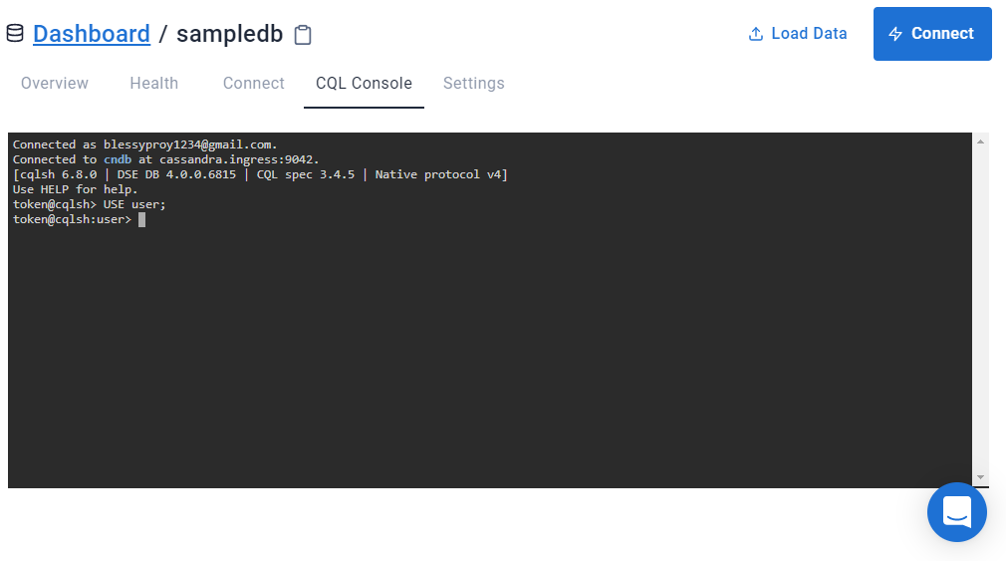

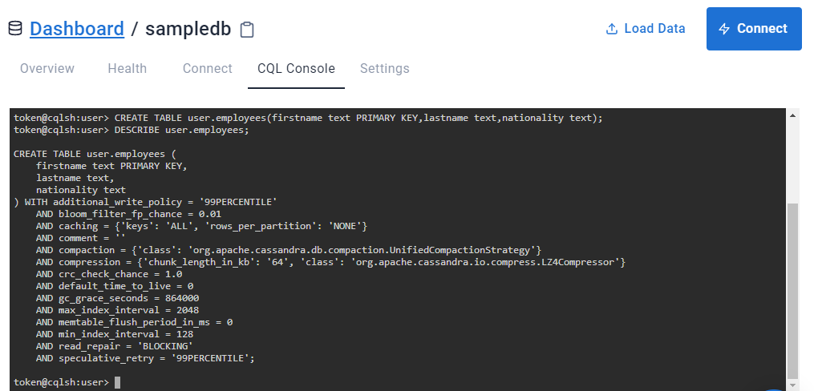

**QUERIES**

1. **INSERTING DATA INTO A TABLE**

Procedure:

* INSERT INTO employees(firstname, lastname, nationality)VALUES ('Jennifer', 'John', 'America');
* INSERT INTO employees(firstname, lastname, nationality)VALUES ('Patricia', 'Robert', 'Paris');
* INSERT INTO employees(firstname, lastname, nationality)VALUES ('Noah', 'Jack', 'London');
* INSERT INTO employees(firstname, lastname, nationality)VALUES ('William', 'Thomas', 'England');

**OUTPUT**

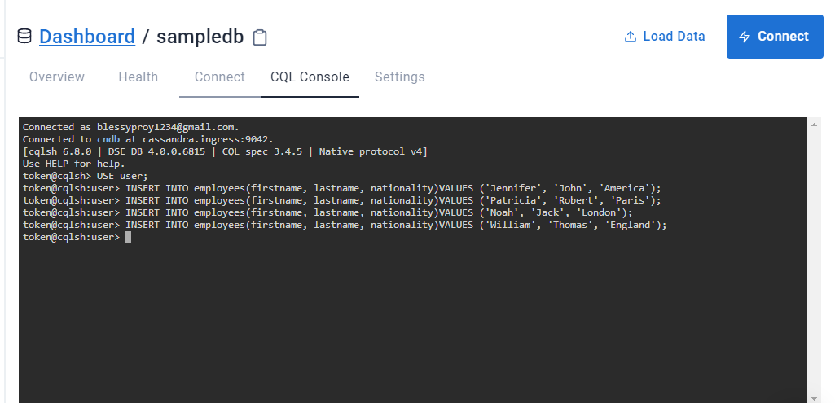

**2.RETRIEVAL OF ALL DATA**

Procedure:

* SELECT * FROM user.employees;

**OUTPUT**

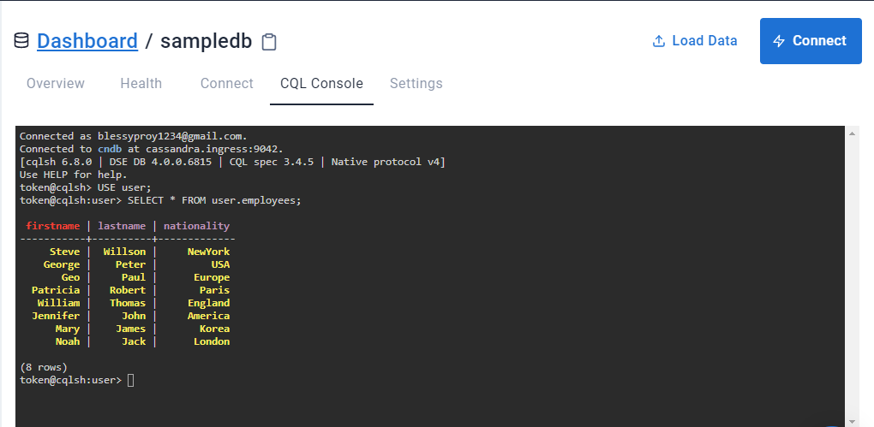

**3.RETRIEVE THE DETAILS OF STAFFS USING CONDITIONS**

Procedure:

* SELECT * FROM user.employees WHERE nationality = 'London' ALLOW FILTERING;
* SELECT * FROM user.employees WHERE firstname = 'Mary' ALLOW FILTERING;

**OUTPUT**

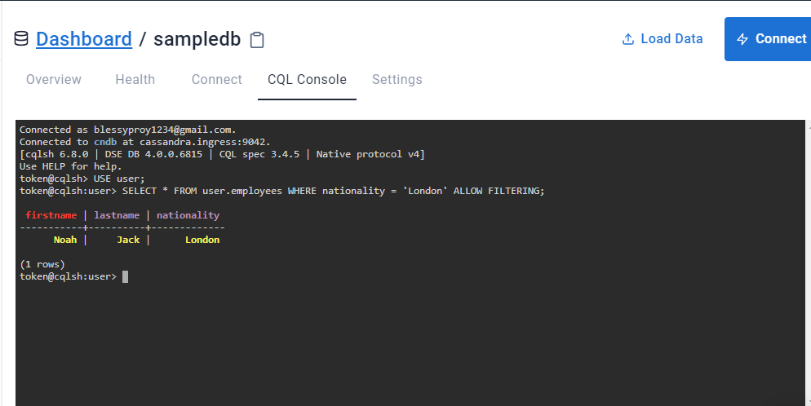

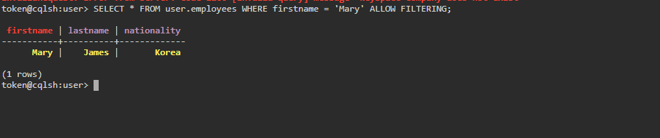

1. **ALTER TABLE command**

* Adding new column ’title’ into the table ‘employees’

Procedure:

* ALTER TABLE employees ADD title text;
* DESCRIBE TABLE employees;
* Add data into that column using update command
* Then displayed the details using select command

**OUTPUT**

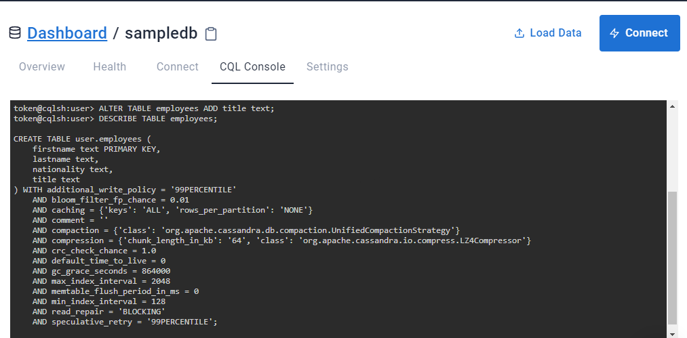

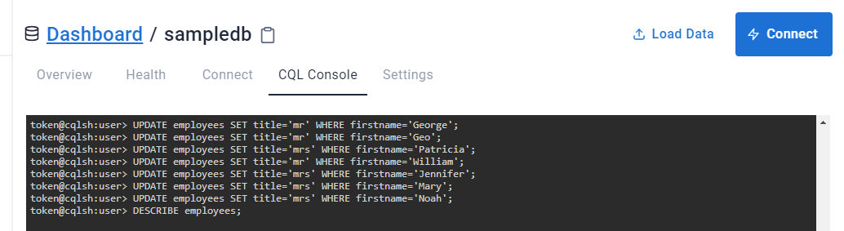

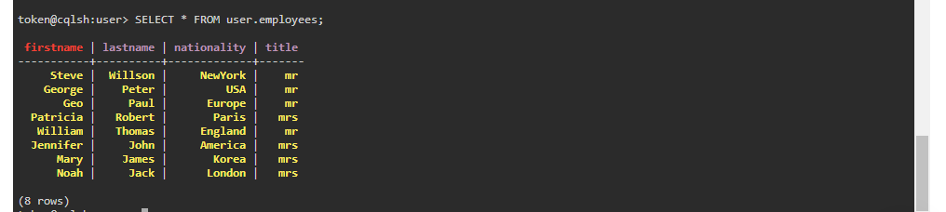

**4.RETRIEVING TIMESTAMPS**

**Timestamps**

Each time you write data into Cassandra, a timestamp is generated for each column value that is updated. Internally, Cassandra uses these timestamps for resolving any conflicting changes that are made to the same value.

Procedure:

* SELECT firstname ,lastname , writetime(lastname) FROM employees;

**OUTPUT**

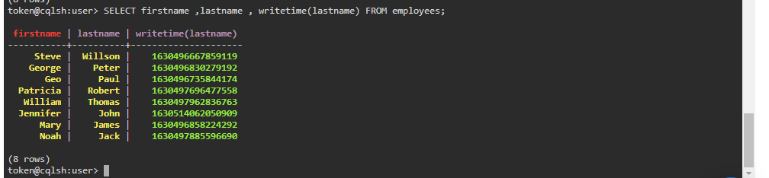

**5.RETRIEVE THE TTL VALUE FOR ‘ Mary’s lastname’**

Procedure:

* SELECT firstname, lastname, TTL(lastname) FROM employees WHERE firstname = 'Mary';

**OUTPUT**

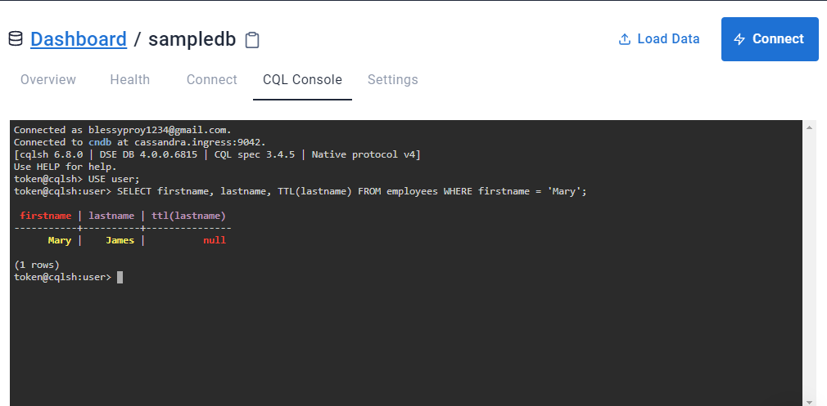

**6. QUERY TO ADD THE IDENTIFIER USING A UUID**

Procedure:

* ALTER TABLE employees ADD id uuid;
* DESCRIBE employees;

**OUTPUT**

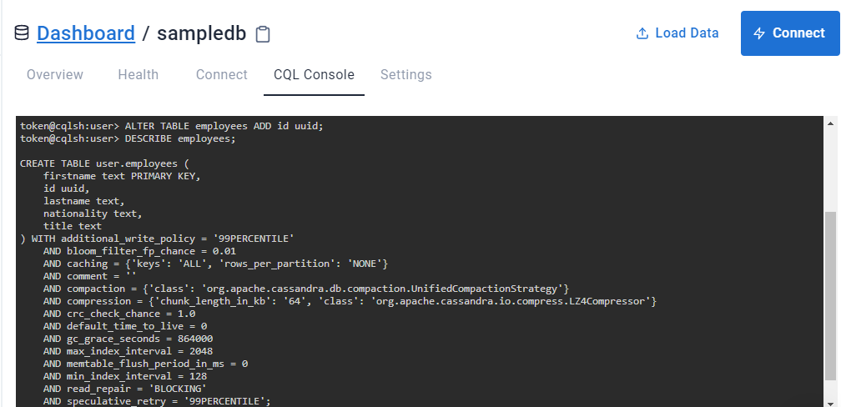

**7.QUERY TO INSERT**  **AN ID FOR MARY USING UUID() FUNCTION AND THEN VIEW THE RESULTS**

**uuid**

A universally unique identifier (UUID) is a 128-bit value in which the bits conform to one of several types, of which the most commonly used are known as Type 1 and Type 4. The CQL uuid type is a Type 4 UUID, which is based entirely on random numbers. UUIDs are typically represented as dash-separated sequences of hex digits. For example:

1a6300ca-0572-4736-a393-c0b7229e193e

The uuid type is often used as a surrogate key, either by itself or in combination with other values.

Procedure:

* UPDATE employees SET id = uuid() WHERE firstname = 'Mary';
* SELECT firstname, id FROM employees WHERE firstname = 'Mary';

**OUTPUT**

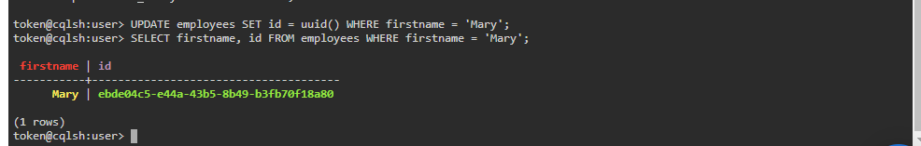

**8.QUERY TO MODIFY OUR STAFFS TABLE TO ADD A SET OF EMAIL ADDRESSES**

**Set**

The set data type stores a collection of elements. The elements are unordered, but cqlsh returns the elements in sorted order. For example, text values are returned in alphabetical order. One advantage of using set is the ability to insert additional items without having to read the contents first.

Procedure:

* ALTER TABLE employees ADD emails set<text>;
* UPDATE employees SET emails = { 'mary@example.com' } WHERE firstname = 'Mary';
* SELECT emails FROM employees WHERE firstname = 'Mary';

**OUTPUT**

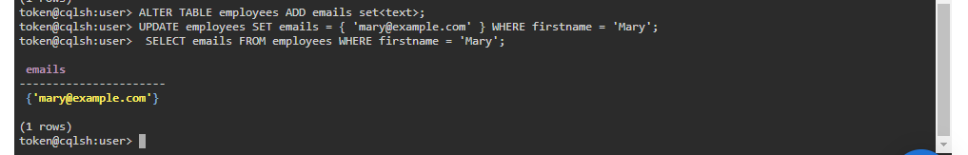

**9.QUERY TO ADD ANOTHER EMAIL ADDRESS WITHOUT REPLACING THE WHOLE SET BY USING CONCATENATION**

Procedure:

* UPDATE employees SET emails = emails + { 'mary.mcdonald.AZ@gmail.com' } WHERE firstname = 'Mary';
* SELECT emails FROM employees WHERE firstname = 'Mary';

**OUTPUT**

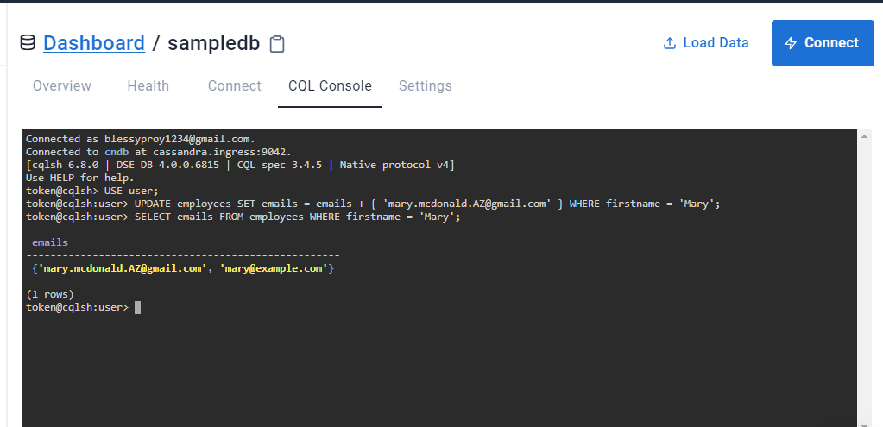

**10.QUERY TO MODIFY OUR STAFFS TABLE TO ADD A LIST OF PHONE NUMBERS AND ADD A PHONE NUMBER FOR MARY AND CHECK THAT IT WAS ADDED SUCCESSFULLY**

**List**

The list data type contains an ordered list of elements. By default, the values are stored in order of insertion.

Procedure:

* ALTER TABLE employees ADD phone_numbers list<text>;
* UPDATE employees SET phone_numbers = ['1-800-999-9999' ] WHERE firstname = 'Mary';
* SELECT phone_numbers FROM employees WHERE firstname = 'Mary';

**OUTPUT**

